1. Count the number of players by the first letter of their surname. List the results in alphabetical order.

SELECT LEFT(LastName,1) AS FirstLetter, COUNT(\*) AS Players

FROM player

GROUP BY FirstLetter

ORDER BY FirstLetter;

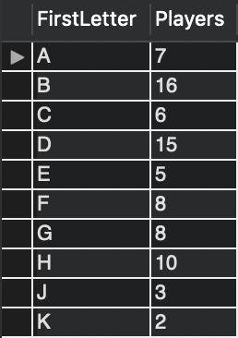

18 rows returned

1. List the game ID, year, and participating team names for every cancelled game.

SELECT GameID, SeasonYear, team1.TeamName, team2.TeamName

FROM game NATURAL JOIN season INNER JOIN team AS team1 ON game.Team1 = team1.TeamID INNER JOIN team AS team2 ON game.team2 = team2.TeamID

WHERE game.T1Score IS NULL AND game.T2Score IS NULL;

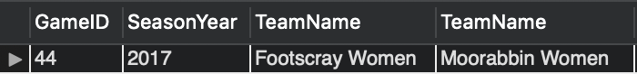

1 row returned

1. List the first and last names of players who have played more than 20 games in total across all competitions.

SELECT FirstName, LastName

FROM player NATURAL JOIN playerteam

GROUP BY playerID

HAVING COUNT(playerID) > 20;

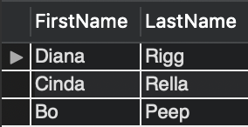

3 rows returned

1. For all current members of the Melbourne City club who have played fewer than 12 games across all competitions, list their first and last names and the number of games they have played. Place the players who have played the most games first.

SELECT FirstName, LastName, COUNT(PlayerID) AS Games

FROM playerteam NATURAL JOIN player NATURAL JOIN clubplayer NATURAL JOIN club

WHERE ToDate IS NULL AND ClubName = 'Melbourne City'

GROUP BY PlayerID

HAVING COUNT(PlayerID) < 12

ORDER BY COUNT(PlayerID) DESC;

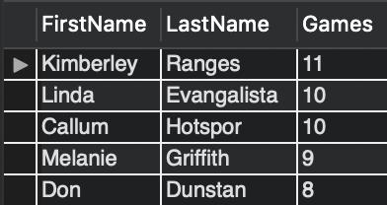

5 rows returned

1. List the names of men who play in the Bingham Trophy but not the Dewar Shield competition.

SELECT DISTINCT FirstName, LastName

FROM competition NATURAL JOIN season NATURAL JOIN game NATURAL JOIN playerteam NATURAL JOIN player

WHERE sex = 'M' AND competitionname = 'Bingham Trophy' AND PlayerID NOT IN (

SELECT PlayerID

FROM competition NATURAL JOIN season NATURAL JOIN game NATURAL JOIN playerteam NATURAL JOIN player

WHERE competitionname = 'Dewar Shield');

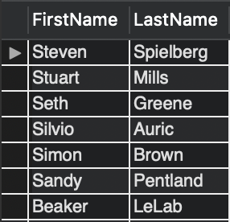

7 rows returned

1. List the full name (in one column) and current club of players who did not play a game in any competition in the 2017 season.

SELECT DISTINCT CONCAT(FirstName, ' ', LastName) AS FullName, ClubName

FROM club NATURAL JOIN player NATURAL JOIN clubplayer

WHERE PlayerID NOT IN (

SELECT PlayerID

FROM player NATURAL JOIN clubplayer NATURAL JOIN season NATURAL JOIN game NATURAL JOIN playerteam

WHERE ToDate IS NULL AND SeasonYear = 2017);

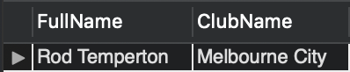

1 row returned

1. Which club currently has the fewest female players? Print the club name and the number of female players in it.

SELECT ClubName, COUNT(ClubID) AS FemalePlayers

FROM clubplayer NATURAL JOIN player NATURAL JOIN club

WHERE Sex = 'F' AND ToDate IS NULL

GROUP BY ClubID

ORDER BY COUNT(ClubID)

LIMIT 1;

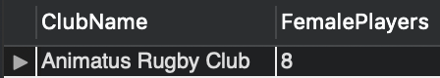

1 row returned

1. A team has a “winless season” when it does not win any of the games it plays in that season. Find the teams that have had exactly one winless season. List the team name and the year in which their winless season occurred.

SELECT DISTINCT TeamName, SeasonYear

FROM season AS Winless NATURAL JOIN game INNER JOIN team ON (TeamID = Team1 OR TeamID = Team2)

WHERE NOT EXISTS (

SELECT \*

FROM game

WHERE SeasonID = Winless.SeasonID AND (

Team1 = TeamID AND T1Score > T2Score OR

Team2 = TeamID AND T2Score > T1Score));

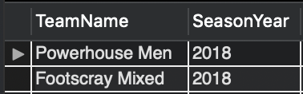

2 rows returned

1. Find the first and last names of players who have played against all their former clubs.

SELECT FirstName, LastName, formerclubs.Played

FROM player NATURAL JOIN clubplayer NATURAL JOIN (

SELECT PlayerID, COUNT(DISTINCT opponent.ClubID) AS Played

FROM team AS opponent INNER JOIN (

SELECT PlayerID, CASE

WHEN Team1 = playerteam.TeamID THEN Team2

ELSE Team1

END AS OpponentID

FROM clubplayer NATURAL JOIN playerteam NATURAL JOIN game

WHERE ToDate IS NULL AND PlayerID IN (

SELECT PlayerID

FROM clubplayer

WHERE ToDate IS NOT NULL)) AS enemy ON opponent.TeamID = OpponentID

WHERE (PlayerID, opponent.ClubID) IN (

SELECT PlayerID, ClubID

FROM player NATURAL JOIN clubplayer

WHERE ToDate IS NOT NULL)

GROUP BY PlayerID) AS formerclubs

WHERE ToDate IS NOT NULL

GROUP BY PlayerID

HAVING COUNT(ClubID) = Played;

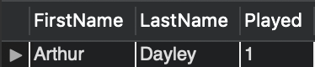

1 row returned

1. How many points did the ‘Melbourne City Women’ team score in the Williams Plate in 2017?

SELECT SUM(CASE

WHEN Team1 = TeamID THEN T1Score

ELSE T2Score

END) AS Points

FROM team NATURAL JOIN playerteam NATURAL JOIN game NATURAL JOIN season NATURAL JOIN competition

WHERE TeamName = 'Melbourne City Women' AND SeasonYear = 2017 AND CompetitionName = 'Williams Plate';

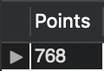

1 row returned